**Users Manual**

**< IT_Capstone 4905 >**

**< Budget Tracker System>**

**Team Member: Andrew Yang, Jian Ma**

**Sponsor: Diana Bergeman**

#### **Approval Signatures**

|  |  |  |
| --- | --- | --- |
| **Approved by: Business Project Leader** |  | **Approved by: IM/IT Project Leader** |
|  |  |  |
|  |  |  |
|  |  |  |
| **Prepared by: Business Project Manager** |  | **Prepared by: IM/IT Project Manager** |
|  |  |  |
|  |  |  |
|  |  |  |
|  |  | **Reviewed by: Quality Assurance Manager** |

This is the section for the control of the outline planning, which teammates or sponsors can edit and update this document. The editor should provide the date and the description of the changes, in order to maintain the development and distribution of revisions.

|  |  |  |  |
| --- | --- | --- | --- |
| **Revision Number** | **Date of Issue** | **Author(s)** | **Description of Change** |
|  |  |  |  |

**Table of Contents**

1. **Project Summary**
2. **Points of Contact**
3. **Introduction**
   1. Purpose, Scope, and Objectives
4. **Getting started**
   1. Setup consideration
   2. User access consideration
   3. Accessing the system
   4. System navigation and organization
   5. Exiting the system
5. **Using the system**
   1. Data input
   2. Filter or sort the data
   3. New Purchase Forms
   4. Queries
   5. Reports
      1. Brief report
      2. Detailed report
   6. Running reports under some criteria
6. **Troubleshooting and support**
   1. Error message
   2. Special considerations
   3. How to contact support
7. **Terms and acronyms**
8. **References (internal and external)**
9. **Any other appendices based of system specific functionalities**
10. **Project Summary**

Create a budget tracking system that allows users to log purchases, expenses, etc., pull up reports on any defined chart string and see pending charges, expended charges, and report to show % of the year that’s gone by, % of funds already spent, amount available to spend, etc.

1. **Points of Contact**

|  |  |  |
| --- | --- | --- |
| Role | Name | Email address |
| Team member | Andrew Yang | andrewyang@my.unt.edu |
| Team member | Jian Ma | jianma@my.unt.edu |
| Sponsor | Diana Bergeman | diana.bergeman@unt.edu |
|  | David Keathly | david.keathly@unt.edu |

1. **Introduction**

In order to analyze the budget of the College of Engineering in UNT, the sponsor needs to use Microsoft Excel to complete the task. However, there are hundreds of data needs to be processed, which makes it very complicated by using Excel. Hence, we decided to use Microsoft Access software to create a more efficient and easy method to help sponsor solve this problem.

* 1. Purpose, Scope, and Objectives
* Create a budget tracking system by using Microsoft Access.
* The product should have a variety of functions to fulfill sponsor’s requirements.

1. **Getting started**
   1. Setup consideration

* Equipment Environment

The project must be performed under Windows operating system, so there are two methods:

* PC with Windows (Windows 10 is preferred)
* Mac user can use virtual machine to install Windows
* Storage Environment

The user needs to install the Microsoft Office software, so the installation of these software will be about 2.6 GB. It is recommended to have more than 3 GB free space on the storage.

* Support Software Environment

In order to use the Access software, we need to install the Microsoft Office.

Go to <https://www.microsoft.com/en-us/education/products/office>, sign in using school email address, and then you can download the Office for free. Follow the instructions to install the software. After installation, the Access software will appear in the start menu. The version number is 16.0.13328.20334, other versions are also acceptable.

* 1. User access consideration

Since the project is a Microsoft Access file, the user only needs to download the project into his/her computer. Since this project is a locally used software, it doesn’t allow for multiple users to work on it at the same time.

* 1. Accessing the system

In order to access the system, the user only needs to double click the Access file to open it. Then you will enter the system and you can begin doing your stuff on it.

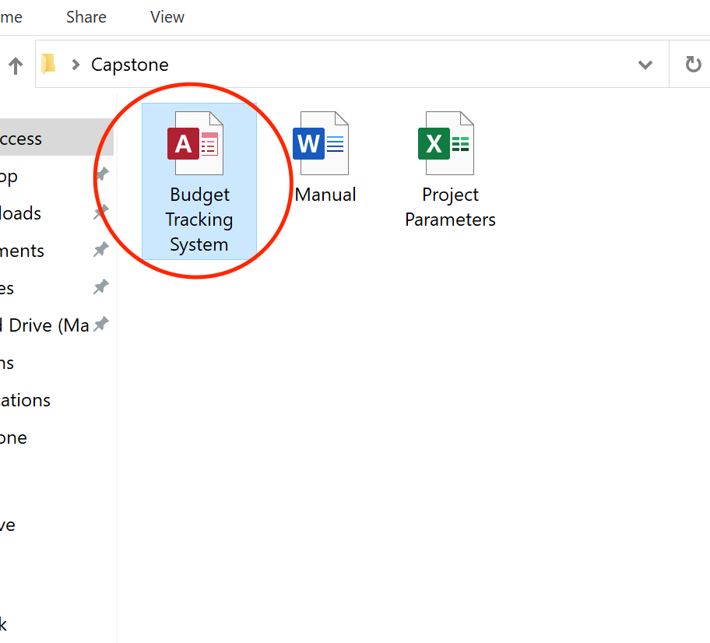

* 1. System navigation and organization

Our system is based on Microsoft Access software, the interface of it is the same as other Access files which include tabs (like File, Home, Create, etc.) and list of objects.

The system contains tables (D line, Fund, Function, Project, Purchase, Purpose) to store the data. The forms are used to add, delete, and save the record. The query is used to query the data under any criteria. The report is used to generate the summary of the specific data from the table.

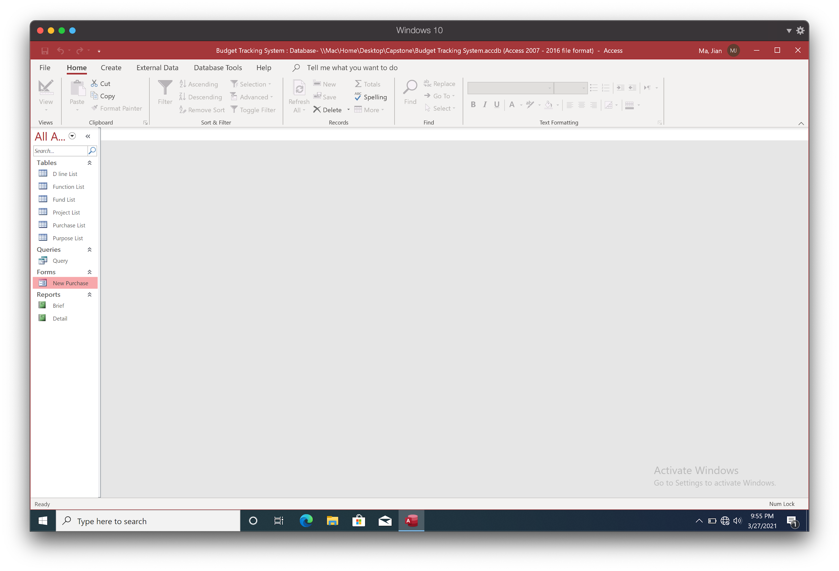

* 1. Exiting the system

In order to exit the system, you can just click the top right button to close the file.

**Remember:** save the file if you have modified the data or performed some other stuff in it.

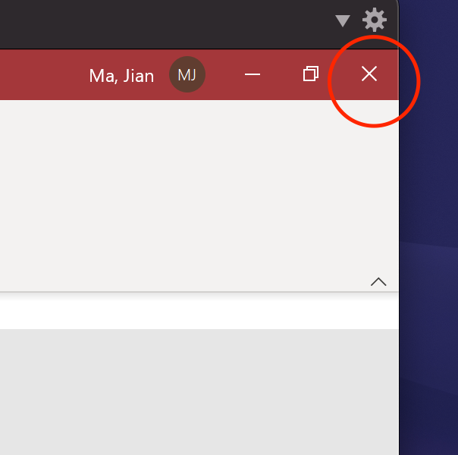

1. **Using the system**
   1. **Data input**

In order to input some data, open the list tables and enter or edit the data in a specific box. Fill the lists (D line, Function, Fund, Project, Purpose) before you make new purchase records.

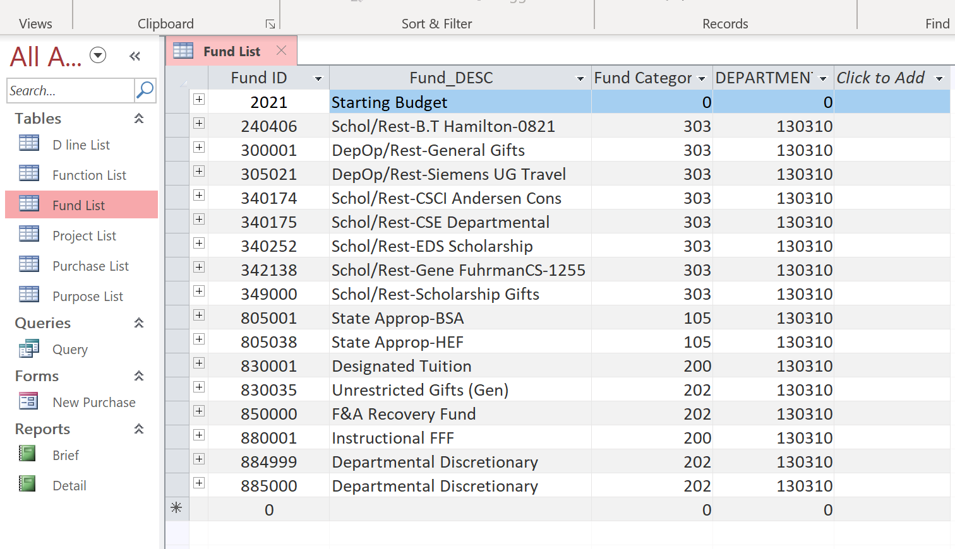

* 1. **Filter or sort the data**

Click the inverted triangle symbol to show the sorting rule.

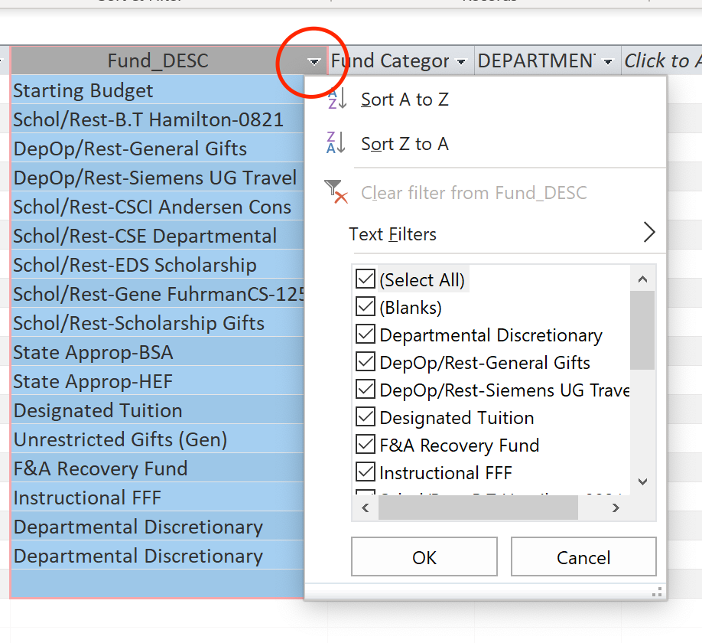

* 1. **New Purchase Forms**

This form can help create new purchase records into the table. When you finish entering the data and save it, the information will be stored in the Purchase List.

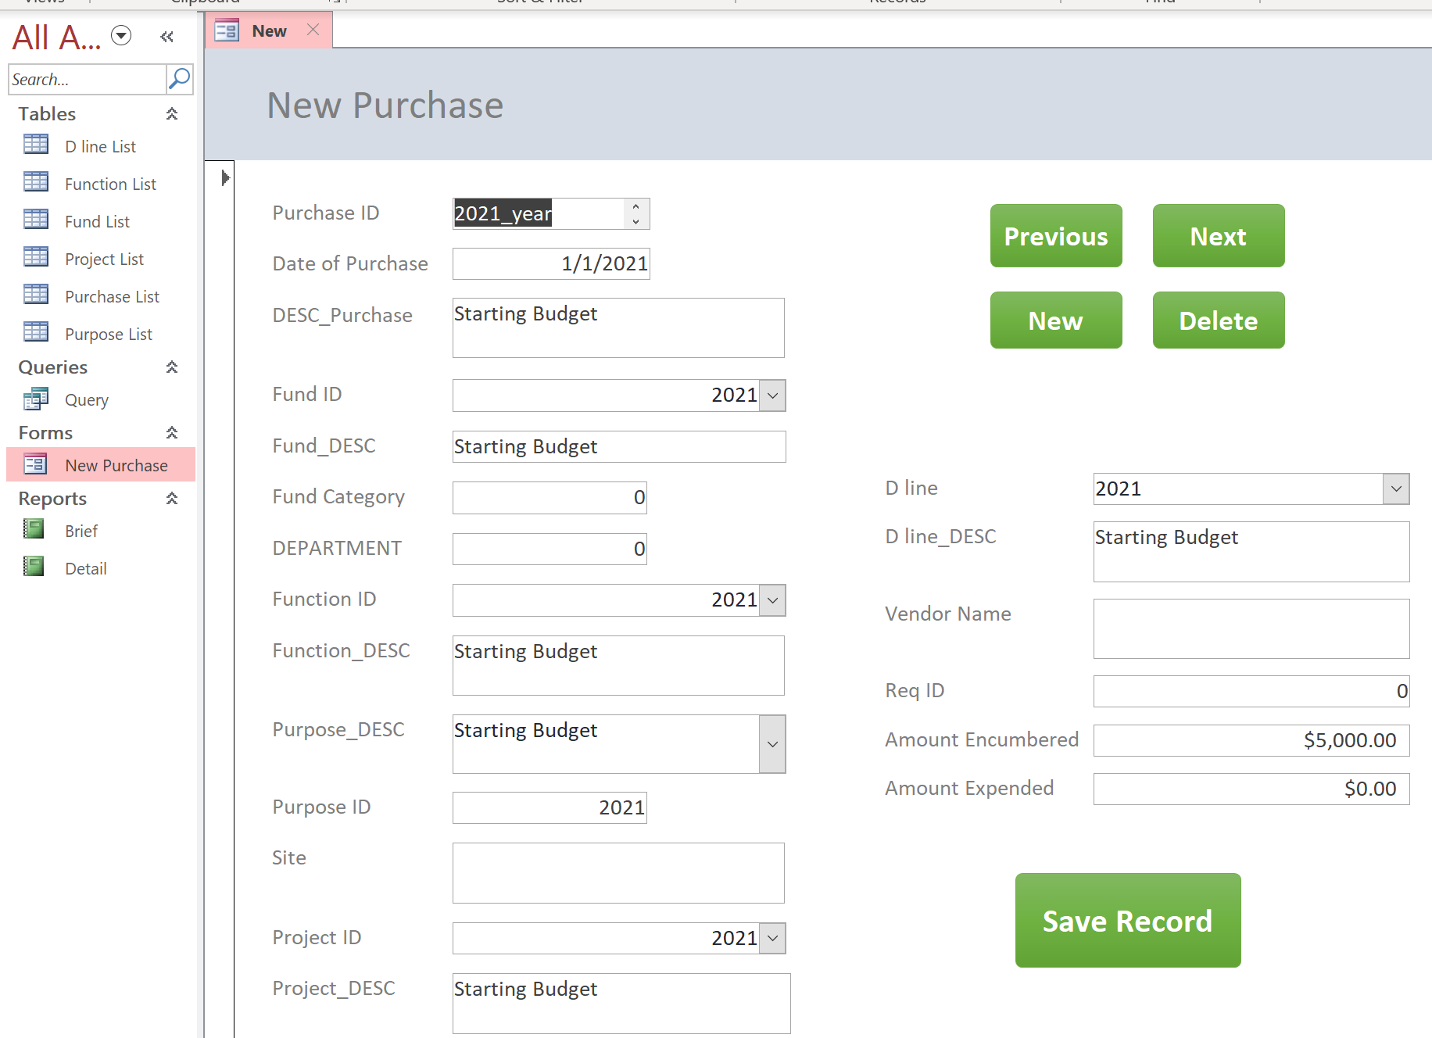

Some combo boxes are used to help fill in the information automatically.

There are five buttons:

* Previous: go to the last record in Purchase List
* Next: go the next record in Purchase List
* New: create a new record in Purchase List
* Delete: delete this record in Purchase List
* Save Record: save this record in Purchase List

**If you want to enter the Starting Budget:**

Type (2021, Starting Budget) into each list (D line, Function, Fund, Project, Purpose) like this:

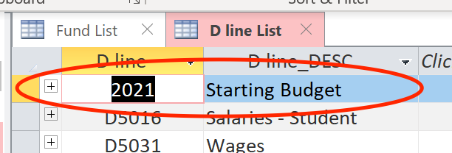 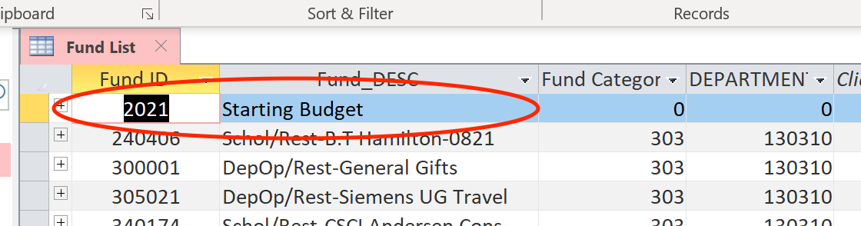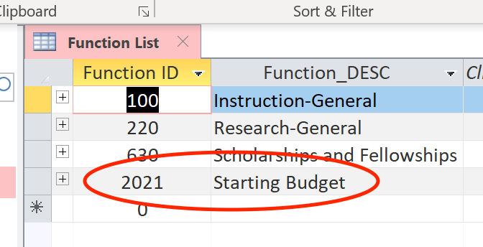 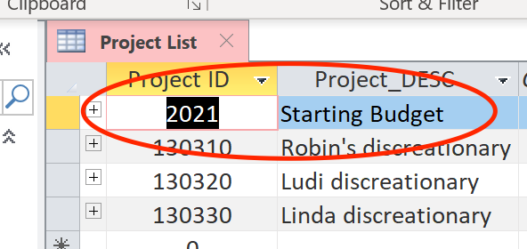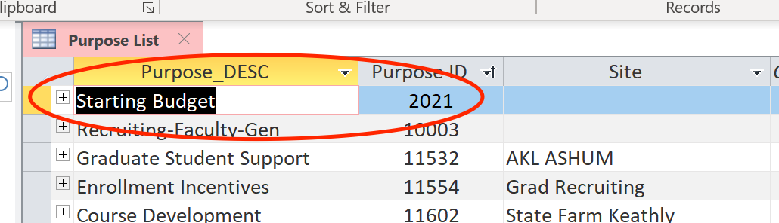

Then, use New Purchase forms to create the starting budget into the Purchase List. Use the drop-down list to select 2021.

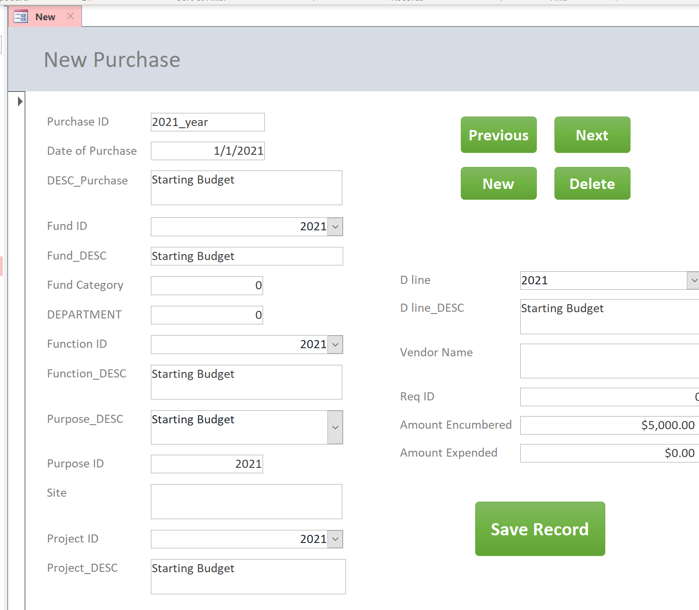

* 1. **Queries**

The query contains all the purchase information.

Also, if you want to query some other time periods or other criteria, you can use the filter to quickly display the information you want.

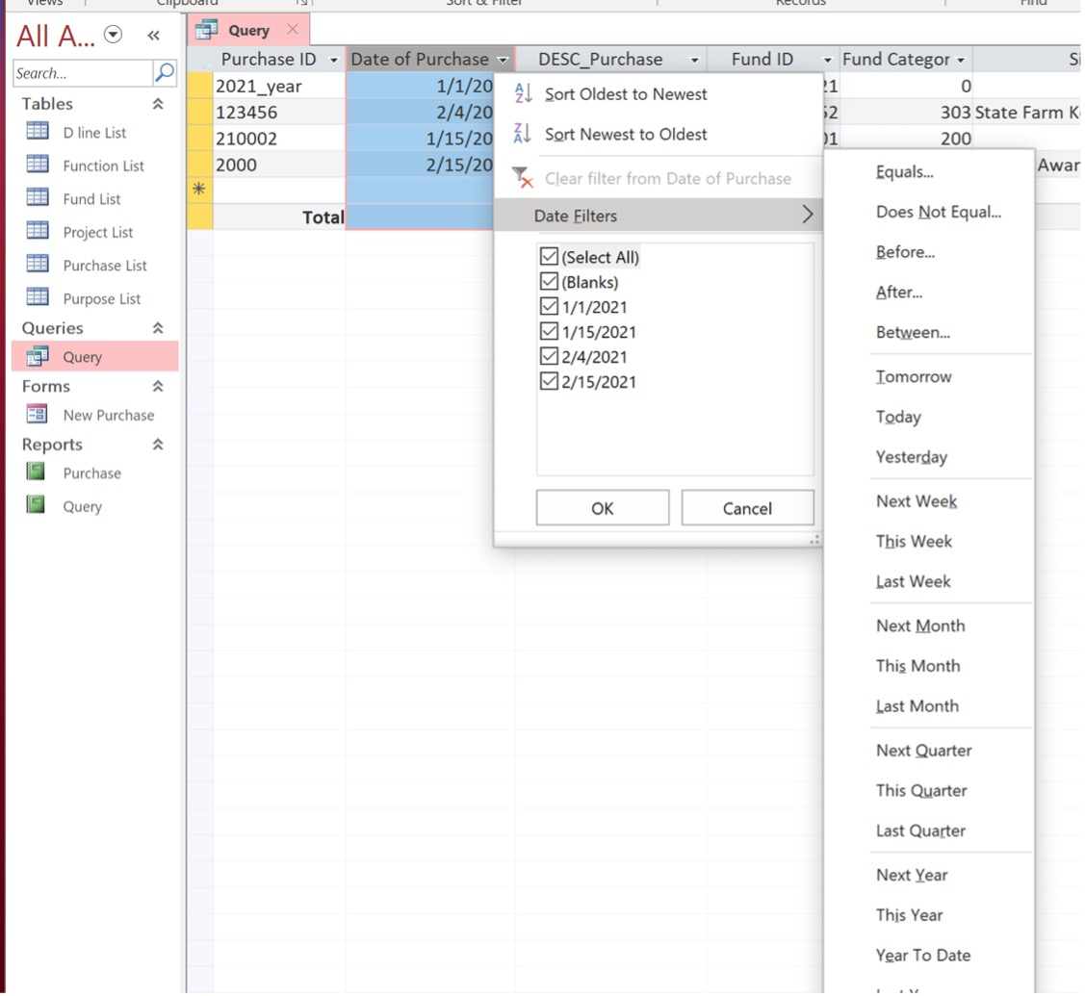

* 1. **Reports** 
     1. Brief report

This will show some brief information (D line, Function ID, Project ID) of the purchase records. It will calculate the percentage of spending, and sum of money you’ve encumbered, expended, or pending.

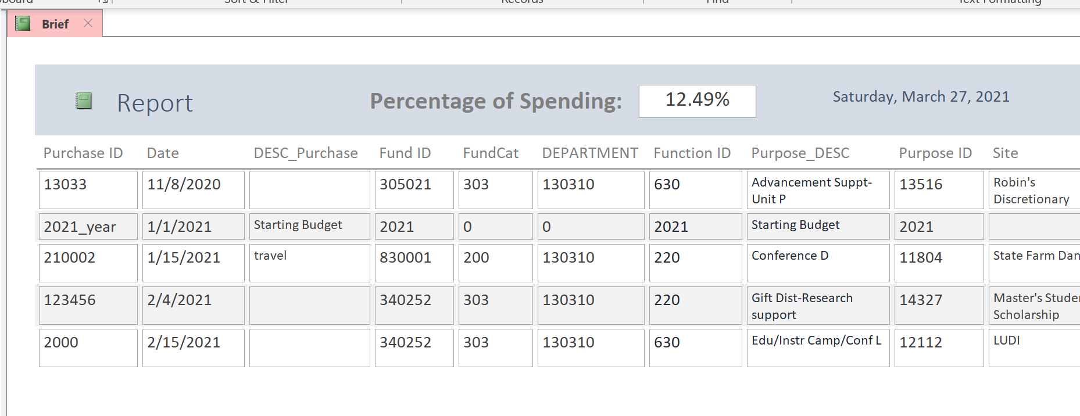

* + 1. Detailed report

This will contain all the detailed information of the purchase records.

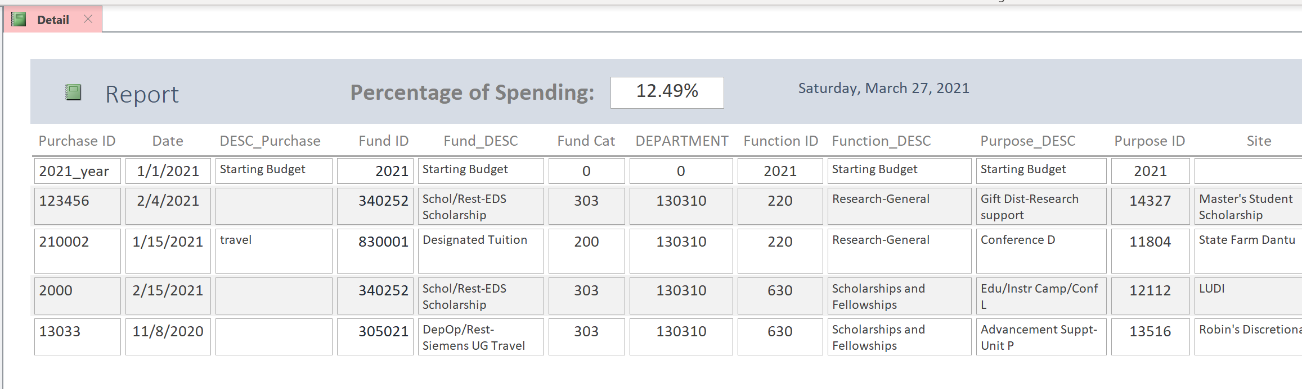

* 1. **Running reports under some criteria**

Example: you want to query 2021’s purchases

* In the Query queries, click (**View** -> **Design View**)

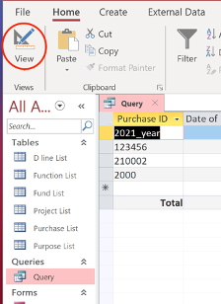 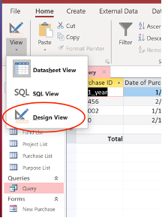

* Enter the criteria: **>=1/1/2021**

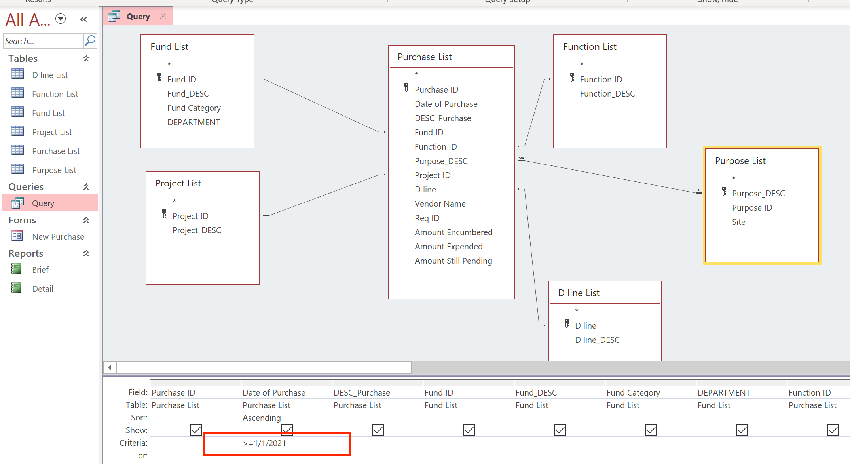

* Go back to **Datasheet View**, **save it**
* Now both reports will display the purchase records in 2021

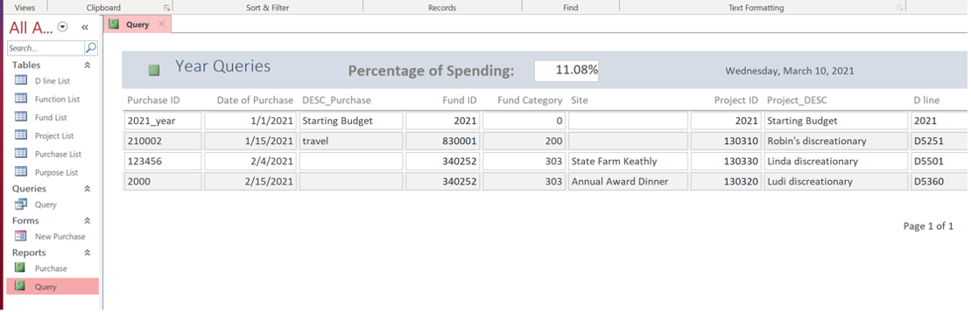

1. **Troubleshooting and support**
   1. Error message

Since our system is based on Microsoft Access software, there’s not any extra error messages created by us. All the error messages are software based.

For example, if you enter the wrong data type, it will automatically notify you.

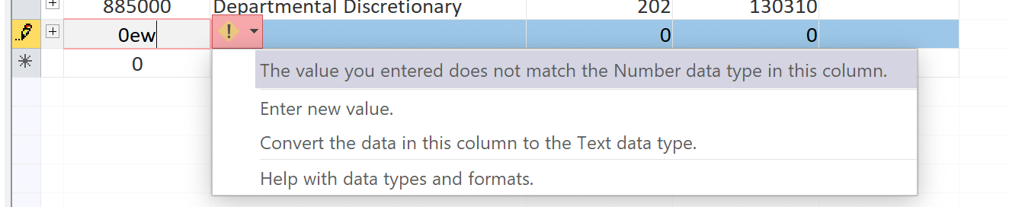

* 1. Special considerations
* When starting to use the system at the first time, remember first to fill the list tables (D line, Fund, Function, Project, Purchase). Then you can use the forms to make new purchase records.
* Every time you add or modify the data, remember to save the file.
* Since our system is locally used, it is better to create backups. You can save this Access file in a hard drive or upload it to OneDrive cloud in case of accidents.
  1. How to contact support

The IT_Capstone 4905 team will be responsible for the system support.

|  |  |
| --- | --- |
| Andrew Yang | andrewyang@my.unt.edu |
| Jian Ma | jianma@my.unt.edu |

1. **Terms and acronyms**

The system is a Microsoft Access software, there’s no other terms or acronyms created in this system.

1. **References (internal and external)**

Since the system is a locally used software, there’s no external references for it.

For the internal reference:

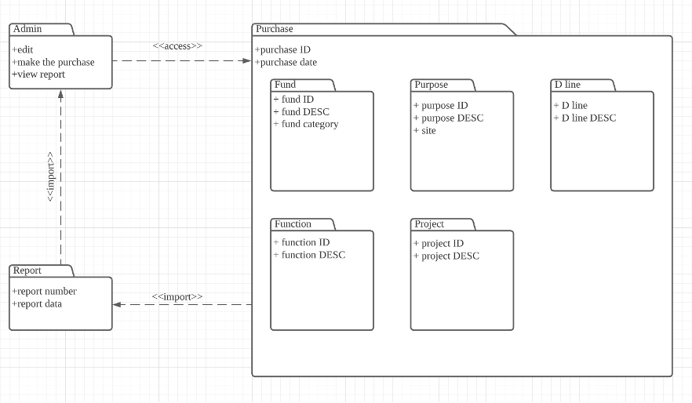

Based on the diagram we created in SRS, our system has some lists which store the information of each category. D line, Function, Fund, Project, and Purpose tables are independent tables which store some sub-data. Also, the Purchase table has some relationships with other tables’ data. So, it’s important to make sure the information of Purchase table will be updated if the sub-table’s data has been modified.

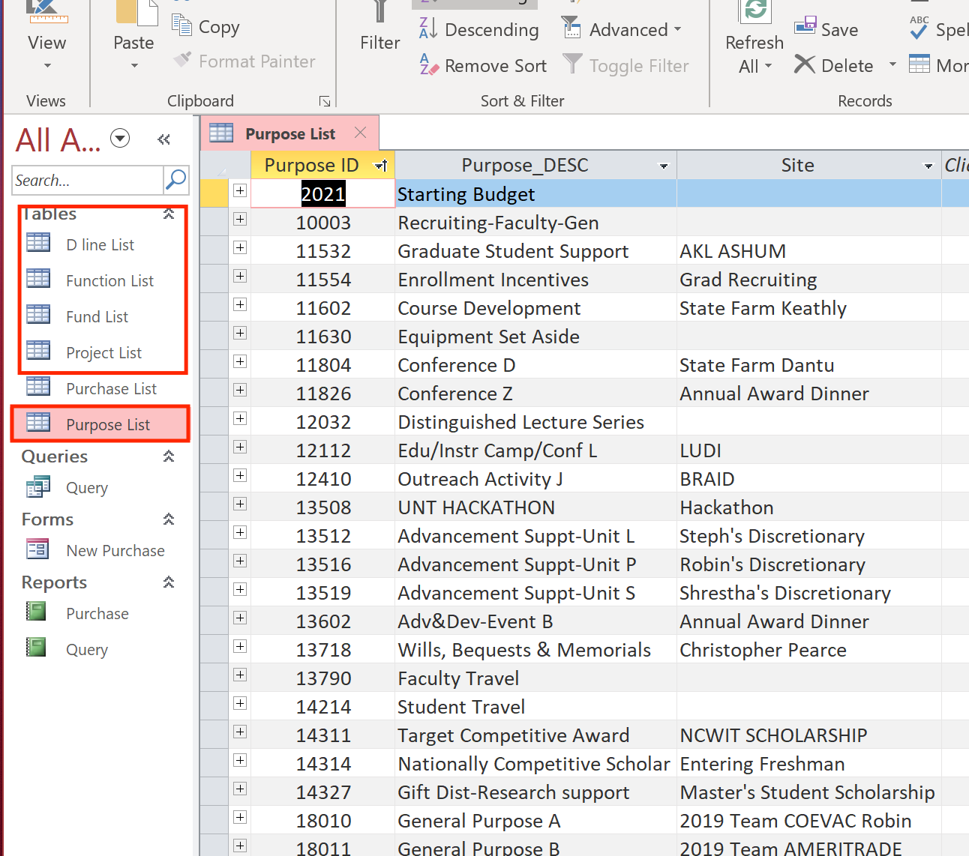 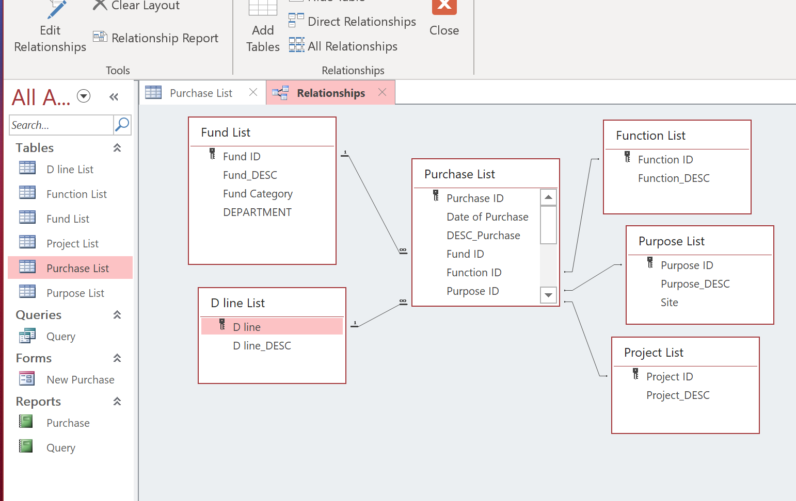

For the forms and queries, they have been set up based on the Purchase List. Once the new record is saved by the forms, that record will be stored into the Purchase List. and the Query queries will automatically be updated.

 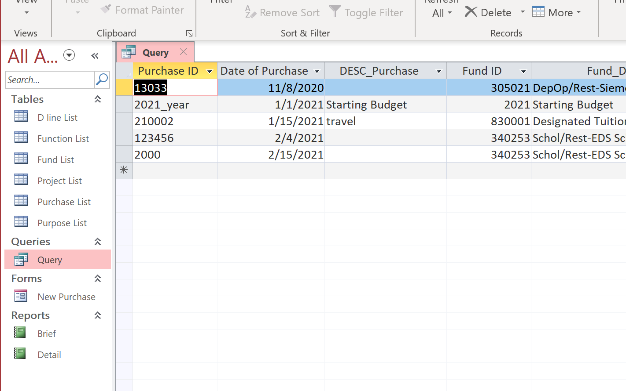

The report is based on the information shown in Query queries. Once giving some criteria in queries, the records in the report will be updated upon it.

1. **Any other appendices based of system specific functionalities**

No other functions need to be specified.